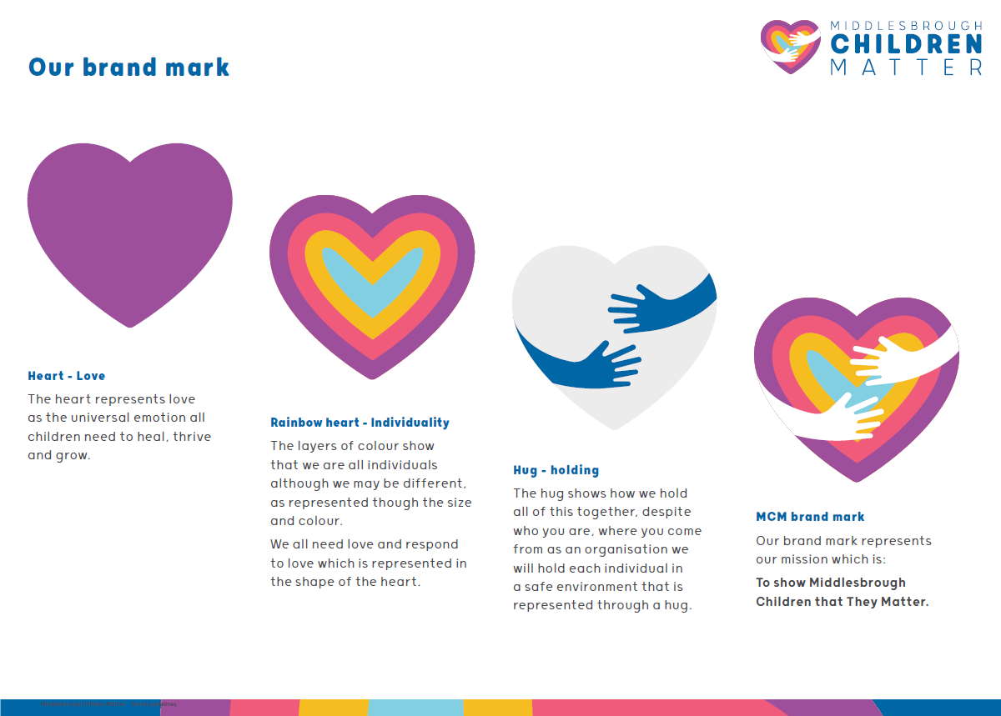



**DOMESTIC ABUSE**

**TOOLKIT**

|  |
| --- |
| **Contents** |
| OPENING POEM 3  impact of domestic abuse on children 4 |
| types of domestic abuse 5 |
| national picture 6  Local picture 8  domestic abuse during covid-19 10  findings from audit 12  Domestic Abuse Process 13 |
| Practice examples 15 |
| Practice guidance 16 |
| Practice / knowledge hubs 17 |
| referrals / services 18  CLARE’S LAW 30  LEGAL ORDERS 32 |
| internal contacts 36 |
| external contacts 37 |
| evidence based tools / safety planning 38 |
| direct work 42 |
| social 43 |
| research 44 |



When they met he was kind, caring, funny and sweet,

Hardly a day went by without a present or treat.

They enjoyed nice dinners and romantic walks along the coast,

Breakfast in bed and poached eggs on toast.

Her friends were in awe, she has finally found her soulmate,

He ticks every box, there’s just nothing to hate.

To them it felt right but to some it moved too fast,

But she knew it was fine as it was going to last.

She knew he worked hard and his job caused him so much stress,

She felt stupid for leaving the house such a mess.

Tomorrow was a new day, she would try even more,

As she scrubbed off the blood from the living room floor.

She thought she had told him she would be home by ten,

He said it was nine and accused her of cheating with other men.

She knew it was easier to just cancel plans or phone in sick,

Rather that than have broken ribs again as they didn’t heal quick.

She tried everything but nothing was ever good enough,

But each time he said sorry and she knows he has it tough.

She wished she could turn to a friend or work mate,

But now her only friends were his friends and she’d been fired from work for too many lates.

She had lost everything and everyone and felt so alone,

With no income, purse, cash or phone.

When she discovered she was pregnant she had hoped it could fix them,

She wasn’t expecting such a beating in the kitchen.

At 16 weeks gestation she mourned the loss of her baby,

And started to wonder if maybe she actually is crazy.

She had nothing left and didn’t know who she was anymore,

As she laid in the pool of blood on the hallway floor.

Her friends brought her flowers and stood together and cried,

They didn’t see the red flags and brushed off the signs.

They felt angry and hurt, she must have been so depressed,

As they said their goodbyes and laid her to rest.

* Rebecca Cheesman

This toolkit has been developed by Rebecca Cheesman as part of

Middlesbrough’s Centre for Practice Excellence.

**Impact of Domestic Abuse on Children**

**Children living with domestic abuse may:**

Have trouble identifying unsafe situations, risky behaviour or unhealthy relationships

Be highly anxious about being a victim or perpetrator in the future;

Be a victim of bullying and unable to be assertive in some situations;

Be extremely withdrawn, isolated and reluctant to trust people;

Suffer physical and emotional harm;

Be over sensitive to conflict, raised voices, peer squabbles;

Be depressed; feel guilty (they cannot stop it), cut off;

Lack empathy and feel out of control;

Stop going to school or abscond from it;

Behave badly at school and perform poorly;

Seem very angry and be easily angered;

Seek attention & seek to control relationships;

Self-harm;

Be in denial; refuse to discuss family situations;

Over achieve to compensate and behave impeccably;

Feel silenced by what is going on / not considered whilst the victim is supported;

Take on adult roles in the home with housework, siblings;

Be reluctant to leave the home or socialise;

Seek to protect the victim;

Appear very self-sufficient and mature (masking their true situation);

Have an unhealthy perspective on what a normal family is;

Feel the loss of the perpetrator and want to see them;

Resent the victim for what has been lost (perpetrator, home, school, friends, etc);

Have been groomed by the perpetrator to blame the victim;

Be encouraged to lie in order to support one or both of the parents;

Fear the perpetrators return or that they will encounter them outside;

Sleep poorly, have nightmares, eating difficulties;

Be more likely to become a victim or perpetrator in the future;

Have difficulty forming relationships in the future.

Children have their own anxieties and support needs;

They need to be supported alongside and separately from the victim

**TYPES OF DOMESTIC ABUSE**

***Taken from the Women’s Aid*** [***website***](https://www.womensaid.org.uk/information-support/what-is-domestic-abuse/)***.***

We define domestic abuse as an incident or pattern of incidents of controlling, coercive, threatening, degrading and violent behaviour, including sexual violence, in the majority of cases by a partner or ex-partner, but also by a family member or carer. It is very common. In the vast majority of cases it is experienced by women and is perpetrated by men.

[Domestic Abuse Act 2021](https://homeofficemedia.blog.gov.uk/2021/04/29/domesticabuseactfactsheet/) states that abuse can be a single incident, but is often a pattern of behaviours, and it takes many forms:

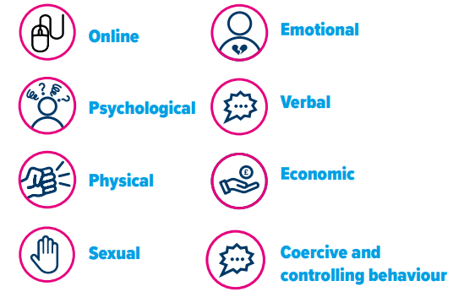

**NATIONAL PICTURE**

**For the 12-month period to year ending March 2020:**

* The Crime Survey for England and Wales showed that an estimated **2.3 million adults** aged 16 to 74 years experienced domestic abuse in the last year (1.6 million women and 757,000 men), a slight but non-significant decrease from the previous year
* The police recorded 758,941 domestic abuse-related crimes in England and Wales (excluding Greater Manchester Police)1, **an increase of 9%** from the previous year; this continues an ongoing trend that may reflect improved recording by the police alongside increased reporting by victims
* Referrals of suspects of domestic abuse-flagged cases from the police to the Crown Prosecution Service (CPS) **for a charging decision fell 19%** to 79,965, from 98,470 in the year ending March 2019
* The charging rate (see [Glossary](https://www.ons.gov.uk/peoplepopulationandcommunity/crimeandjustice/bulletins/domesticabuseinenglandandwalesoverview/november2020#glossary)) was **73%, a decrease** compared with the previous two years (74% in the year ending March 2019 and 76% in the year ending March 2018)
* Over three-quarters of domestic abuse-related CPS prosecutions were successful in securing a **conviction (78%),** a similar level to the previous year

Available data sources show that during the coronavirus pandemic:

* There was a **7% increase in police recorded offences** flagged as domestic abuse-related between March and June 2020, compared with the same period in the previous year; however, there has been a gradual increase in these offences over recent years, therefore it cannot be determined whether this can be directly attributed to the coronavirus pandemic
* There was generally an increase in demand for domestic abuse victim support services, including a 65% increase in calls and contacts logged by the National Domestic Abuse Helpline between April and June 2020, compared with the first three months of the year
* Increases in demand for domestic abuse support were particularly noticeable following the easing of lockdown measures in mid-May, such as a 12% increase in the number of domestic abuse cases handled by Victim Support in the week lockdown restrictions were eased, compared to the previous week; this reflects the difficulties victims faced in safely seeking support during the lockdown
* Increases in demand for domestic abuse victim services do not necessarily indicate an increase in the number of victims, but perhaps an increase in the severity of abuse being experienced, and a lack of available coping mechanisms such as the ability to leave the home to escape the abuse, or attend counselling.

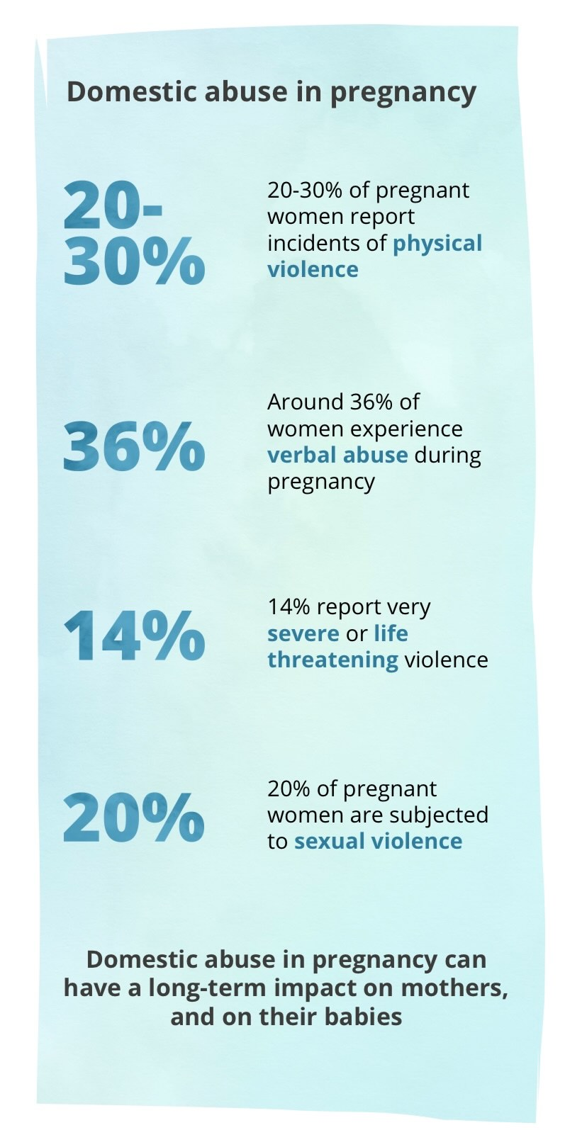[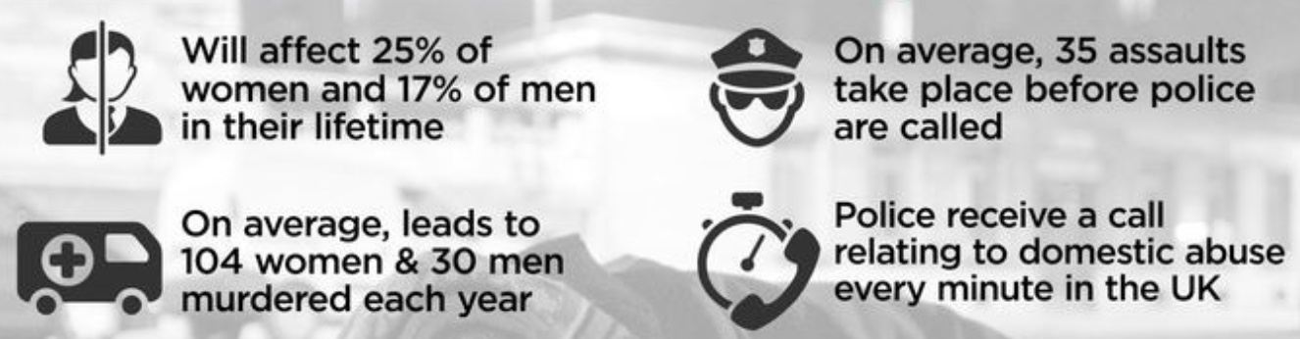](https://data.london.gov.uk/blog/domestic-violence-infographic/)**Domestic Abuse…**

**LOCAL PICTURE**

**In the 12 months from April 20 – March 21:**

Of 20096 contacts received into the MACH during this time period, 4747 of these reported domestic abuse as the stated issue (whereby domestic abuse was identified as the main factor/reason for the contact).

[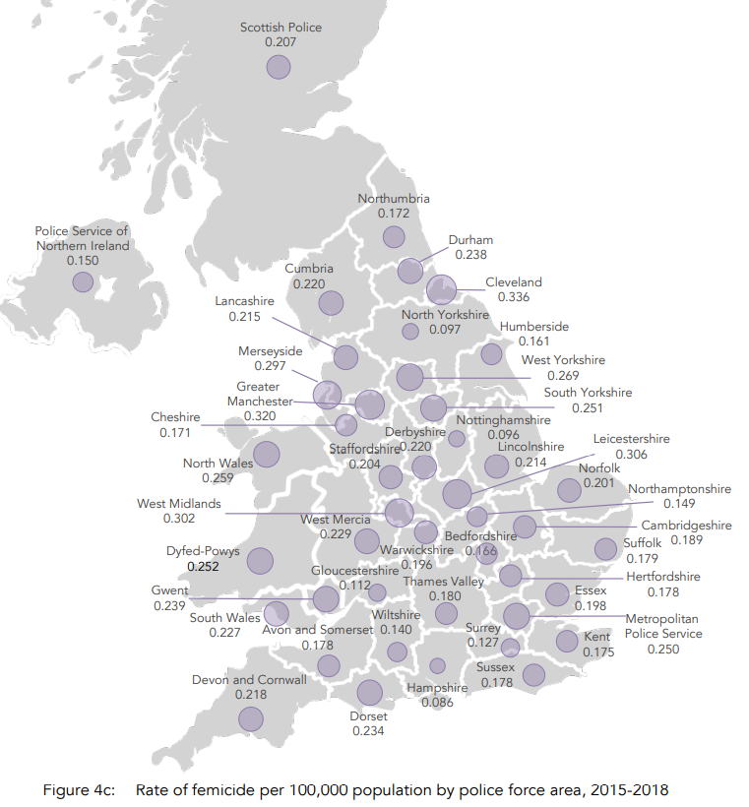](https://www.femicidecensus.org/wp-content/uploads/2020/11/Femicide-Census-10-year-report.pdf)

**DOMESTIC ABUSE DURING** **COVID-19**

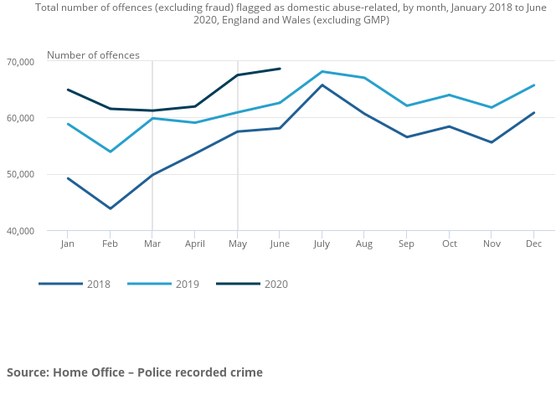

**The ‘What Works’ Centre looked at what Middlesbrough front door did in response to the COVID-19 pandemic and domestic abuse, this was taken from their** [**report**](https://whatworks-csc.org.uk/blog/digging-deeper-into-covid-innovations/)**:**

At Middlesbrough, they instituted two related changes to engagement with Middlesbrough’s Multi-Agency Risk Assessment Conferences (MARAC) – a fortnightly information sharing and action planning meeting for victims of domestic abuse, held between local police, probation, health, children’s services and other specialists. Firstly, they shifted to a policy where assistant team managers within Middlesbrough’s Multi Agency Children’s Hub were required to attend all virtual MARAC meetings in full (where previously, case workers would only feed into discussions related to families on their caseload). The practitioners felt that this improved the timeliness of information sharing and action by all partners. More generally, those we spoke to felt this closer way of working sustainably galvanised multi-agency partnerships in Middlesbrough, which will persist in the future. Secondly, Middlesbrough conducted a review of CSC cases (both open and closed) that had been heard at MARAC. The purpose was to re-assess the risks of domestic abuse, and revise safety plans and the frequency of visits and direct work. Practitioners felt this helped services better identify families where domestic abuse is a key issue, and ensured that children were better protected in the face of potentially higher risks brought about by the pandemic and lockdown. The practitioners we spoke with also valued that the review enabled assessment teams to reflect on decision-making in previous cases of domestic abuse, and apply learnings to future risk assessments.

**FINDINGS FROM** **AUDIT**

**Audit has identified the following in relation to domestic abuse:**

* Assessments aren’t specialised when it comes to domestic abuse and risk assessments aren’t completed to inform the assessment
* The DASH RIC isn’t updated either following the referral or throughout involvement
* Direct work isn’t linked to the presenting issue of domestic abuse
* Plans aren’t outcome focused, i.e. we will ask parents to attend DA services but not focus on what we want to achieve by this so progress is not measurable. They are also generic and not specific to each child and family i.e. attending DA services may not be what works for each family and we may need to offer more individualised support.
* Safety plans regurgitate what’s in the overriding plan as opposed to being completed with the child and family to identify how the risk of domestic abuse and the child being exposed to this will be reduced.
* When parents are separated and the perpetrator doesn’t live in the home, the perpetrator/absent parent is often not included in the assessment or planning.
* There seems to be a lack of response to cases heard at MARAC. It appears that workers are either not always aware that their cases are heard at MARAC or if they are they don’t respond to this or acknowledge the MARAC minutes that are recorded on LCS.

**DOMESTIC ABUSE PROCESS**

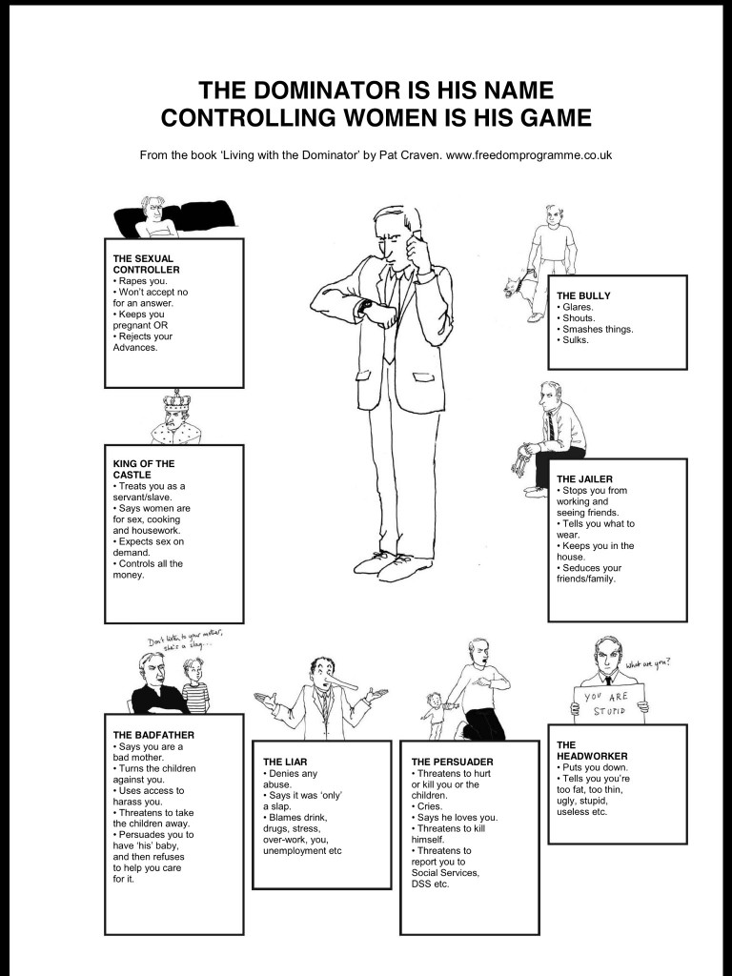

**PRACTICE EXAMPLES**

|  |  |  |
| --- | --- | --- |
| **Type of example** | **Description** | **Link / Document** |
| DASH RIC | Anonymised examples of DASH RIC | *Thank you to Leanne Smith, My Sister’s Place, for your contributions.* |
| Safety plan – adult | Safety plan in relation to parents who have recently separated but the risks of domestic abuse remain present/high given the recent separation. | *Thank you to Nicola Poole, MACH, for your contributions.* |
| Safety plan – child/young person | Hannah’s safety plan – risks of domestic abuse in the household, age 10.  Chloe’s safety plan – contextual safeguarding/online/CSE risks, age 15. |  |
| Initial screening / enquiries | CAFCASS Distinguishing domestic abuse and harmful conflict tool  DASH RIC questions/MARAC referral (liaise with Nicola Poole) – documents above  Immediate safety planning – examples above to guide |  |
| Case supervision & Assessment | Guidance when completing assessments and case supervision. |  |

**PRACTICE GUIDANCE**

**What do our children and young people in Middlesbrough want from us?**

**Best practice guidance from Xavier Davies, Apprentice Youth Training & Development Officer:**

1. Be **curious**, be **reflective** (is the YP’s behaviour or appearance changing? Do they have money going missing?)
2. Visit the **home** where the young person is living, and places they **visit** (consider during virtual meetings the possibility of the perpetrator being present/listening/coaching the YP with what to say or not say)
3. Look around, what do you **see**? (think of unknown clothing, shoes, signs of property damage)
4. How is the young person **presenting** in different environments, what do our **observations** tell us?
5. Look at **patterns**, think of that young person’s **lived experiences** and complete a **chronology**
6. Consider how the young person views **relationships**, what relationships have they grown up around? Do they need some **educative** support around **healthy relationships** and **signs** of domestic abuse?
7. Think of all forms of domestic abuse **not just physical**.
8. Consider the use of ID badges, **ask** the young person if they would prefer you to take them off to reduce their anxieties.
9. Don’t ask them to repeat their **story** again.
10. Think about the **language** you use.
11. Ask the young person to **tell you** about themselves, not their story, **them**.
12. Don’t ask hard hitting questions that may cause worry once you’ve left. **Explain** everything.
13. Include all **multi-agency** professionals in meetings, could they provide some support? Consider their **expertise**.
14. Consider the limited resources available for young **men** or teenage **boys** experiencing domestic abuse, treat this sensitively and seek the most appropriate accommodation. Consider how they may **feel**.
15. Think about a young person’s worry about leaving **siblings** behind or **pets**, what can be done to promote that **contact** or even keep them **together**?

**PRACTICE / KNOWLEDGE HUBS**

***Clickable links:***

[Intranet](https://intranet.middlesbrough.gov.uk/childrens-services-extranet)

[Hot Topics](https://intranet.middlesbrough.gov.uk/childrens-services-extranet/hot-topics)

[Tri.x procedures](https://www.proceduresonline.com/resources/covid19/)

[CCinform hub](https://www.ccinform.co.uk/knowledge-hubs/domestic-abuse-knowledge-and-practice-hub/)

[Domestic abuse bill](https://www.communitycare.co.uk/2021/05/13/new-domestic-abuse-legislation-means-social-workers/)

[BASW England Domestic Abuse Guidance for social workers](https://www.basw.co.uk/system/files/resources/181181_basw_england_domestic_abuse_guidance_v5.pdf)

Strengthening Practice folders - *if you don’t have one of these please speak to Siobhan Davies (PSW)*

[Domestic abuse and COVID](https://safelives.org.uk/news-views/domestic-abuse-and-covid-19)

[One minute guides](https://www.middlesbrough.gov.uk/community-support-and-safety/domestic-abuse)

[Femicide Census](https://www.femicidecensus.org/wp-content/uploads/2020/11/Femicide-Census-10-year-report.pdf)

Child Safeguarding Practice Reviews: [Fred](https://stscp.co.uk/wp-content/uploads/2021/06/Child-Safeguarding-Practice-Reports-Fred-Jun21.pdf) / [Liam Executive Summary](https://stscp.co.uk/wp-content/uploads/2021/09/Child-Safeguarding-Practice-Report-%E2%80%93-Liam-%E2%80%93-April-2021.pdf)

Middlesbrough Domestic Homicide Reviews



[Domestic Abuse Strategy](https://www.middlesbrough.gov.uk/sites/default/files/Preventing-domestic-abuse-strategy-2019-2021.pdf)

**REFERRALS / SERVICES**

[Local and national services](https://www.middlesbrough.gov.uk/community-support-and-safety/domestic-abuse/im-working-someone-suffering-domestic-abuse-professionals)

(Nov – March 2021) Covid-19 Recovery

|  |  |
| --- | --- |
| **Domestic Abuse Services**  ***Follow above link for further contact details*** | **MACH Senior Domestic Abuse Practitioner**  Based in the Middlesbrough MACH and provides support and advice to professionals and families.  Nicola Poole – MACH.  **Middlesbrough Council Practioners**  **Domestic Abuse Housing Solutions Coordinator**  To provide advice and assistance to service users accessing Housing Solutions service who are experiencing homelessness / threat of homelessness as a result of domestic abuse.  **Domestic Abuse BAME Case Worker**  Delivering Black, Asian, Minority Ethnic (BAME) community based support for female victims experiencing violence and abuse such as so called honour based violence, forced marriage and FGM. The post holder will provide high quality short to medium term advocacy and support based on client led needs and risk assessment. |
| **My Sisters Place**  My Sisters Place are commissioned to deliver the following:  <https://www.mysistersplace.org.uk/>    **Protect and Support**  Referral and Response, IDVAs, support workers, community based recovery programmes, Counselling Service, Sanctuary Scheme, IRISi programme with Middlesbrough GPs.  **Freedom Programme** is a 12-week course that will help women to understand the beliefs held by abusive men and the effects of abuse upon children. The programme aims to help participants to help themselves and increase their self-confidence.  **Protect and Support Children and YP service**  Counselling and Therapeutic Services for Children and YP experiencing / at risk of DA, Dedicated IDVA, Group work Interventions, Prevention in schools and colleges.  **IDVA** (independent domestic violence advocate) support workers who offer advice to women to keep them safe and provide support with legal advice i.e. non-molestation orders. Independent of other services such as Police and Social Care, however they can work with a range of agencies to advocate for women when needed.  **Counselling**  Counselling is a talking therapy that involves a trained therapist listening to you and helping you find ways to deal with emotional issues.  **ME TIME** ME TIME Children and Young Peoples Service is part of My Sisters Place Domestic Abuse Service and is a confidential trauma informed therapeutic service that provides a range of age appropriate therapies for children and young people aged 4 to 18 years who are/have been impacted by traumatic experiences of domestic abuse. They MUST be in a safe and stable situation at the point of referral to ensure that they can be fully supported through the therapeutic process and receive support from a parent/carer to prevent any further de-stabilisation or trauma.  Speak to service reps for a referral/discussion:  MACH: Nicola Poole  Assessment: Rebecca Cheesman  SCP: Siobhan Bage  Early Help: Elaine Carter  **Sanctuary** the Sanctuary Scheme aims to prevent victims of domestic violence becoming homeless by providing security in their home. It is a victim-centred initiative, with the aim of making it possible for victims to remain in their own homes and feel safe. The scheme is run as a partnership with the Sanctuary Scheme Co-ordinator based at My Sisters Place, working closely with Crime Prevention Team at Cleveland Police, Cleveland Fire Brigade, and Belle Property Group. Middlesbrough Council funds the scheme.  **Male Victims**  Support for male victims on a one to one basis. Referrals through the main service. An assessment of risk and needs is completed to identify the support needs and safety plan. Appointments take place at St Marys Centre with the male victim’s worker.  **LGBTQI+**  National LGBT+ Domestic Abuse Helpline  (Galop) T: 0800 999 5428 E:  [help@galop.org.uk](mailto:help@galop.org.uk)  Hart Gables: 01642 675509 |
| **Stalking Services**  National Stalking Helpline Phone: 0808 802 0300 [National Stalking Helpline website](https://www.suzylamplugh.org/Pages/Category/national-stalking-helpline)  Paladin, National Stalking Advocacy Service Providing advocacy to anyone at risk of serious harm or homicide from a stalker. Phone: 020 3866 4107 [Paladin website](https://paladinservice.co.uk/)  Suzy Lamplugh Trust Aiming to reduce the risk of violence and aggression through campaigning, education and support. Phone: 0808 802 0300 [Suzy Lamplugh Trust website](https://www.suzylamplugh.org/) |
| **Teesside Age Uk  Safe Steps**  1 F/T IDVA Support and Advice to those aged 50+  [front.office@ageukteesside.org.uk](mailto:front.office@ageukteesside.org.uk) |
|  | |
| **Sexual Violence /Sexual Exploitation / Sex work** | **SARC (Sexual Assault Referral Centre)**  SARC work with anyone who has experienced rape or sexual assault, they offer the following services.  Confidential Advice. Anonymous report to police or advocacy on your behalf with direct report to police. Specialist medical examinations. Specialist forensic examination, including non-intimate samples. Storage of forensic samples, giving you time to decide on reporting to police. Support through Police interview. Risk and need assessment to make sure you are safe. Referrals to external agencies with the appropriate consent for specialist counselling and therapeutic support. Ongoing support from an Independent Sexual Violence Advisor (ISVA).  Professional referral: <https://www.sarcteesside.co.uk/professional-referral/>  Self-referral: <https://www.sarcteesside.co.uk/support-for-you/online-referrals/> |
| **ARCH** A registered charity based in Teesside offering free and confidential counselling and ISVA support to people who have been affected by rape or sexual abuse no matter how long ago the experience may have been.  Professional referral: <https://www.dpmscloud.com/external/referralformorgarch>  Self-referral: <https://www.dpmscloud.com/external/referralformselfarch>  **ISVA CYP** ISVA for children and young people support up to the age of 17 years old who have been affected by sexual abuse. Sexual abuse of a child, either by an adult or, sometimes, by an older child, involves an abuse of power and of trust.  **ISVA ADULT** ISVA stands for Independent Sexual Violence Advisor. This service gives you free and confidential access to a specially trained advisor, who can offer you practical help and support.  An ISVA is completely independent of all other agencies and the police. Their only interest is in supporting you. They can support you whether you choose to report to the police or not. It is their role to make sure that you have the information you need to make an informed choice.  If you do report, they will work with the various agencies on your behalf, to make sure you have all the relevant information about your case and ensure that your voice and opinion is heard throughout the investigation.  **ARCHWAY PROJECT** An ARCHWAY ISVA is a specialist service that can support people involved in or exploited through the sex industry who have experienced rape or sexual assault.  We are a fully inclusive service and as such work with anyone aged 18 and over. We can support you whether the assault was recent or historic, no matter who the perpetrator was; punter or otherwise. We are here to support you whether you want to report to the police or not.  We understand that there may be barriers to coming forward and talking about your experiences, but we can offer a discreet, safe space to do so without judgement. We will be sensitive to your needs and move at your pace. It’s not about telling you what to do but supporting you to make informed choice.  **COUNSELLING** ARCH North East provide free, confidential and specialist counselling one-to-one counselling to survivors of sexual violence, no matter how long ago it happened. Counselling gives you the opportunity to explore your feelings within a comfortable and safe environment. Helping you to understand and manage your own feelings or emotions. |
| **A Way Out**  A Way Out is an outreach and prevention charity which aims to engage, empower and equip vulnerable and excluded women, families and young people to live lives free from harm, abuse and exploitation and to reduce life limiting choices and behaviour.  01642 655071  <https://www.awayout.co.uk/>  **Liberty** Our Liberty Project, originally founded in 2002, delivers trauma informed and asset based advocacy and support services to women living with multiple complex needs, and specifically supporting on street sex workers. The service is delivered via evening and daytime outreach in Stockton and Middlesbrough, one-to-one support, locally based drop-ins and in-reach into the local women’s prison, HMP & YOI Low Newton and into Middlesbrough Police’s custody.  Liberty has two distinct delivery elements:  1) a dedicated wrap around service aimed at women who sell sex on the street/are sexually exploited providing bespoke one to one support. 2) a support for other women whose lives are affected by other factors, such as those with learning difficulties, mental health problems, or who are experiencing poverty and homelessness but who are not involved in sex work.  **Blossom Project**  Blossom supports at-risk young women aged 13 – 24 who are facing a range of vulnerabilities. Issues include mental health and wellbeing, family/carer relationship breakdown, NEET, experience of domestic abuse, involvement with substance misuse and experience of exploitation. The support provided by Blossom is trauma informed and focussed upon working with girls and young women to strengthen capabilities. Blossom accepts referrals from a variety of agencies across Teesside such as; social care, education providers, mental health agencies, police, housing, health, youth services and self-referrals. On a practical level, this consists of a balance between regular one to one support and crisis providing direction and incorporating needs; group work providing a six weekly rotation of course content, with each session planned and reviewed by the service users.  **RISE**  A Way Out’s Families Service complements all areas of A Way Out’s project area providing bespoke person centred support to each benefiting family by delivering a whole family approach and co - coordinating the work and action of partner agencies addressing need and sharing information. A Way Out’s RISE Family Service upholds positive relationships with professional services such as Social Care and Early Help. Working as part of a multi-agency approach to personify the best interests of clients and build trust in other service provides. Holistic support on an individual basis is attained by working in partnership with other agencies such as mental health and wellbeing services, education providers, substance misuse organisations and local community projects. Empowering clients to have choice and achieve outcomes in line with personal goals. |
|  | |
| **Peer Support / Befriending** | **The Switch Project**  The Nacro SWITCH project provides comprehensive packages of support to vulnerable women aged 16 and older who face a range of health, social, financial, educational or housing needs, to enable them to regain positive control of their lives.  01642 223551  <https://www.nacro.org.uk/>  We work with them to build confidence, self-esteem and to address issues such as social isolation, domestic violence and drug and alcohol abuse, and support them to get into education, training or work. We have a team of outreach workers dedicated to delivering one-to-one work, group work, training and wellbeing workshops. The project also has a very successful mentoring programme, pairing trained volunteers with vulnerable women within our communities. |
|  | |
| **Refuge / Supported Accommodation for Vulnerable Women / Families** | **MBC Housing Options Team** |
| **Changing Lives Refuge**  As of October 1st 2021 Changing Lives has become the service provider responsible for delivering  Middlesbrough Domestic Abuse Refuge.  The referral form would need to be completed and returned to Changing Lives [middlesbroughrefuge@changinglives.cjsm.net](mailto:middlesbroughrefuge@changinglives.cjsm.net) to enable them to undertake assessment. Any Emergency placements will be dealt with quickly and they will aim to make a decision within the hour. Occasionally this response may be delayed due to difficulty getting information / checks etc but if this is the case the referrer and service user will be updated on this.  At the moment Changing lives are not registered with Routes to Support (although this hopefully will be resolved in next few weeks). Harbour, My Sisters Place, EVA and Foundations all have access to this system and can be contacted to make those enquiries. If no refuge space is available via Routes to Support and emergency accommodation is required during office hours contact  Middlesbrough Housing Solutions 01642 726800 and explain this clearly and that emergency accommodation is required.    [middlesbroughrefuge@changinglives.cjsm.net](mailto:middlesbroughrefuge@changinglives.cjsm.net)  **01642 861788**  **Out of hours: 07812672818**  **Refuge outside of Middlesbrough area:**  **Harbour: 03000 20 25 25 (24 hours)** |
| **Thirteen Housing**  Domestic Abuse Coordinator - Support to those with tenancies with Thirteen Housing. |
| **Penrith Road**  Penrith Road provides accommodation for families who are homeless in Middlesbrough.  The project offers 12 two-bedroom and two three-bedroom flats with access to a communal area, laundry facilities and outside play area.  A crash pad is also available for homeless 16-17 year olds for a maximum stay of four weeks. Staff members are available 24 hours per day.  The service we provide at Penrith Road helps residents to move on to full independence, giving them the skills to successfully manage their future permanent tenancy. |
| **NACRO**  This service provides self-contained leased and managed properties and shared homes in the Teesside area, including in County Durham, Middlesbrough, Redcar and Stockton-on Tees, to individuals or families in need of housing, including those moving on from supported or insecure housing.  Our support includes intensive housing management support which is additional to the services an ordinary landlord might provide. Support includes the provision of repairs and maintenance, out-of-hours emergency service, an increased number of health & safety visits and inspections, and on-going liaison with other agencies involved in the provision of services to the tenant.  Tenants must be referred via agencies such as Local Authorities Housing Options team, Local Authority Housing Services, other supported housing providers, local voluntary agencies, Probation (NPS / CRC), local approved premises and the Police/Integrated Offender Management.  01642 223551  <https://www.nacro.org.uk/> |
| **Stages Academy**  The STAGES Academy is a Places of Changes Scheme offering 48 units of accommodation. Each client receives a thorough needs and risk assessment before their acceptance on to the service to make sure the best support package is in place.  Each client is allocated a support worker to help them develop their own support plan, to address any problems or issues the client may have and to help the client move towards independent living. |
|  |  |
| **Perpetrators Service** | **Harbour**  Domestic Abuse Perpetrator Programme – Harbour's Men's Service works with men who are abusive and controlling towards their partners and demonstrate their intention to change these behaviours. The focus of the service is very clearly upon increasing the safety of partners and children and to reduce the incidents of domestic abuse within these relationships. The service incorporates a women's safety service and works alongside victim services and statutory agencies to monitor behaviour and continually assess risks through timely information sharing.  The Middlesbrough Men's Service is offered in partnership with Families Forward to ensure the needs of the whole family are understood and met.  The programme is a mix of assessment, group work and one to one work appointments and participants will be expected to engage for a period of 30 weeks in total. |
|  | |
| **Support with finance / benefits** | **Middlesbrough Council's Welfare Rights Unit**  The **Welfare** **Rights** Unit provides specialised, independent and confidential advice, as well as representation on benefits and tax credits, and encourages the take-up of benefits. |
|  | |
| **Employee/Employer Guidance** | **(Internal) Under ‘Domestic Abuse Support’ using** [**this intranet link**](https://intranet.middlesbrough.gov.uk/human-resources/health-and-wellbeing-services-and-information/health-and-wellbeing)  **Other guidance:**  [Domestic Abuse and the Workplace](https://www.tuc.org.uk/sites/default/files/Domestic_Violence_And_The_Workplace_0.pdf)  [Employers Guidance](https://safelives.org.uk/sites/default/files/resources/DV%20Employer's%20guidance%20FINAL%20Update%203%20-%20SafeLives%20rebranded.pdf)  [Domestic abuse wellbeing toolkit for employers](https://www.bitc.org.uk/wp-content/uploads/2021/07/bitc-wellbeing-toolkit-domesticabuseforemployers-june2021.pdf)  [Global Domestic Violence & Abuse Policy](https://www.unilever.com/Images/final-domestic-violence-policy-2021_tcm244-559645_en.pdf) |
| **National helpline** | **The freephone, 24-hour National Domestic Abuse Helpline 0808 2000 247**  **Women’s Aid England Directory:**  [**www.womensaid.org.uk/domestic-abuse-directory**](http://www.womensaid.org.uk/domestic-abuse-directory)  **Refuge National DA Helpline** [**Website**](https://www.nationaldahelpline.org.uk/en)  **Women’s Aid Live Chat:**  [**https://chat.womensaid.org.uk**](https://chat.womensaid.org.uk) |
| **BSL support** | **Refuge’s British Sign Language** [**service**](https://www.nationaldahelpline.org.uk/en/bsl)  **Sign Health: Text, email or video (BSL**  **contact available):**  [**https://signhealth.org.uk/contact**](https://signhealth.org.uk/contact) |
| **Pet Fostering** | **Pet Fostering** [**services**](https://www.refuge.org.uk/get-help-now/what-about-pets/) |
| **No recourse to public funds** | **Information from** [**Southall Black Sisters**](https://southallblacksisters.org.uk/need-help/abused-women-with-no-recourse-to-public-funds/)  [**The Angelou Centre**](https://angelou-centre.org.uk/?page_id=94)  **Angelou Centre (Newcastle)**  [referrals@angelou-centre.org.uk](mailto:referrals@angelou-centre.org.uk)  0191 2260394  **Rights of Women** run an immigration advice line that you can call on [020 7490 7689](tel:020%207490%207689) (Mon & Thurs, 10am–1pm & 2pm–5pm). It will also advise you on your immigration and support options. You can search for an immigration adviser on the Office of the Immigration Services Commissioner website at <https://home.oisc.gov.uk/adviser_finder/finder.aspx>.  You can also contact one of the organisations that provides advice to migrants listed at the end of this leaflet, or contact a local advice or law centre. You should always check that the person you see for immigration law advice is professionally qualified. You can check by calling the Officer of the Immigration Services Commissioner on [**0345 000 0046**](tel:0345%20000%200046). (Note that this is not a freephone number).  **[Destitution Domestic Violence (DDV)](https://www.gov.uk/government/publications/application-for-benefits-for-visa-holder-domestic-violence)**  **[Concession (Shelter, 2021)](https://www.gov.uk/government/publications/application-for-benefits-for-visa-holder-domestic-violence)** |

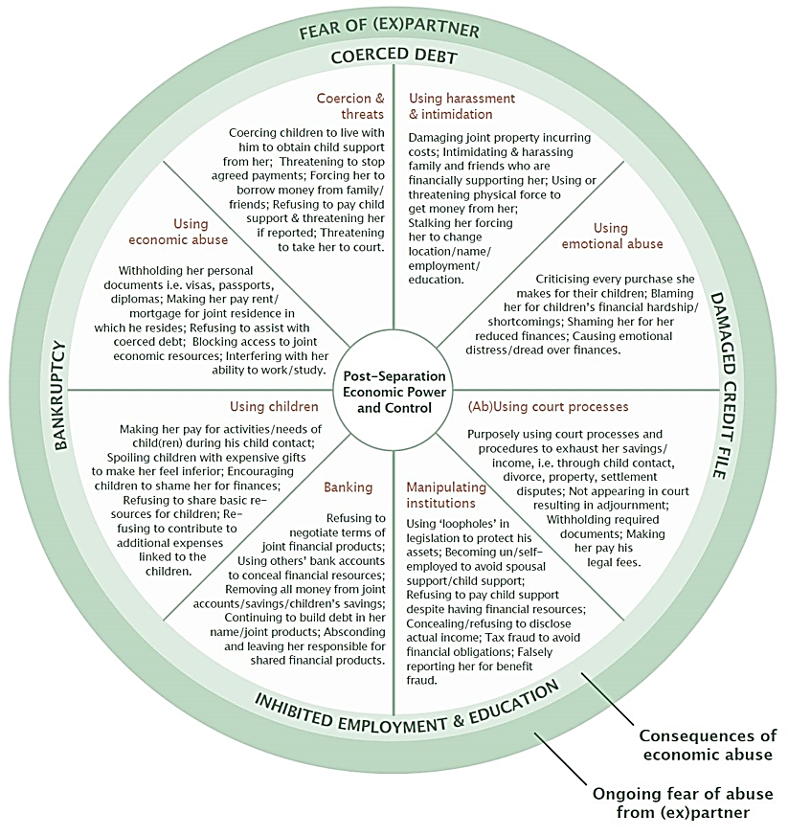

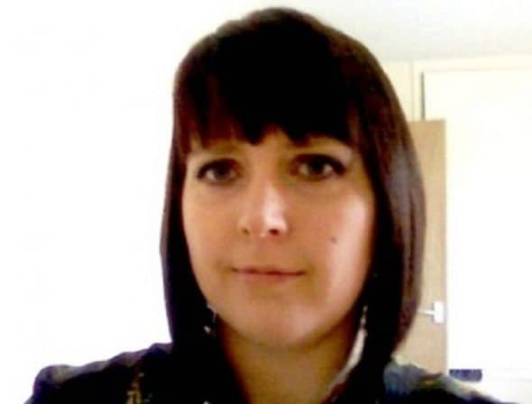**CLARE’S LAW**

**What is the Domestic Violence Disclosure Scheme or 'Clare's Law'?**

The Domestic Violence Disclosure Scheme (DVDS) allows people to make enquiries with the police about an individual they are in a relationship with, or who is in a relationship with someone they know, where there are concerns that this individual may be violent towards their partner. The scheme is also referred to as Clare’s Law, named after Clare Wood, who was murdered by her ex-partner, who had a history of violence towards women.

This law applied to all people, regardless of gender or sexuality; it should not be viewed solely as a mechanism for women to make enquiries about male partners.

There are two aspects to the Domestic Violence Disclosure Scheme - **Right to Know** and **Right to Ask**.

**Right to Know** refers to the obligation police have to disclose information to individuals without it being requested, if they consider that information suggests the individual is at risk of harm from domestic violence.

**Right to Ask** refers to the rights of members of the public to apply to the police for a disclosure of specific information for the purposes of protecting individuals from domestic abuse.

**What information may be disclosed?**

The police may disclose the following relevant police information in relation to a subject, under either ‘The Right to Know’ obligation or the ‘Right to Ask’ application:

* Convictions for an offence related to domestic violence, which are not yet considered ‘spent’ under the Rehabilitation of Offenders Act (1974)
* History as a serial perpetrator of domestic violence; i.e. committed domestic violence acts against two or more victims
* Intelligence about previous violent offending, which may include cases not proceeded with, or previous concerning behaviour towards partners
* Concerning behaviour by the subject towards the potential victim, which may include a pattern of behaviours relating to exerting coercive control

The police have a duty to protect members of the public from crime, and are allowed to balance the subject’s right to confidentiality against a potential victim’s right not to suffer harm from them.

**How can members of the public make an application under the DVDS?**

Individuals can make contact with the police in a number of ways:

* using the 101 non-emergency telephone number
* in person at a police station
* by speaking to a police officer on the street

There are four stages to the process.

**Initial contact and information gathering**: A police officer will speak to the applicant and take details about the partners involved, what prompted the enquiry, and when and where it is safe to make further contact with the applicant. If a crime is alleged to have taken place at this point, then this will be investigated and responded to in line with existing DV procedures. Initial checks will be run to establish if there are any immediate concerns.

**Face to face meeting to complete the application**: If the application progresses, the applicant may need to attend a face to face meeting with the police. The purpose of this meeting is to obtain further information about the relationship between the partners to help assess the risks, establish whether there are any children in the household, and check the identity of the applicant. The police may run checks and speak to other agencies about information they hold.

**Multi-agency meeting to consider disclosure**: The final decision about whether to disclose will be made by the police and other key safeguarding agencies (e.g. probation, prison service) who will discuss the information provided by the applicant and any relevant information from agencies. If they decide to disclose, they will decide who should receive the information and any safety plans which need to be in place to protect potential victims.

**Disclosure of information**: The decision to disclose or not to disclose will be relayed to the applicant in person. If information is shared, the applicant will be asked to sign a written undertaking that they will not share this information further. No written information is given to an applicant, but the conversation is recorded verbatim and kept on police records.

**LEGAL ORDERS**

There is an increasing range of legal orders that can be used to protect survivors of domestic abuse.

#### [Police orders](https://www.victimsupport.org.uk/crime-info/types-crime/domestic-abuse/getting-legal-help/#0aa763c36223246f2)

The police now have powers to serve a Domestic Violence Protection Notice (DVPN) on an abusive partner who presents an ongoing risk of violence. This will be provided in writing and served to the abusive partner by a police officer.  The order lasts for 48 hours and requires the abusive partner to leave the premises and not contact the victim. This can be extended further (up to 28 days) by a magistrate at court, who can grant a Domestic Violence Protection Order (DVPO).

#### [Criminal law](https://www.victimsupport.org.uk/crime-info/types-crime/domestic-abuse/getting-legal-help/#6dd415290ae803381)

Domestic abuse can include other criminal behaviours such as assault, stalking, coercive control, criminal damage and sexual crimes. You have the right to be protected under criminal law if your partner has demonstrated any of these behaviours.

In a criminal law case, when a person is sentenced they may also have a restraining order imposed on them. Different restrictions will be placed on the offender, depending on the severity of the case. Find out more about [sentencing](https://www.victimsupport.org.uk/going-court/sentencing).

#### [Civil law](https://www.victimsupport.org.uk/crime-info/types-crime/domestic-abuse/getting-legal-help/#1af2abefdeb96c700)

Survivors of domestic violence can apply to civil courts (family proceedings courts or county courts) for an injunction or court order to help protect them. The most common types of court orders are:

* non-molestation orders
* occupation orders
* prohibited steps order

#### [Non-molestation orders](https://www.victimsupport.org.uk/crime-info/types-crime/domestic-abuse/getting-legal-help/#e5829904241f7386a)

This type of court order is used to stop someone from pestering, attacking, threatening or harassing you or your children. Each order is unique and will take your individual circumstances into consideration. When making the order, the magistrates will take into account your health, safety and well-being, and consider any children involved. The magistrates will also assess how they think an order will help the situation.

Civil courts need less proof than a criminal court, but they still need evidence of a deliberate incident affecting you or a child before imposing a court order. This is where photographs of injuries or property damage can help, as they can form part of the case for an injunction, along with the statement, to show that there has been violence.

If you need an emergency non-molestation order, you can apply for it ‘without notice’. This is helpful if you need immediate protection. Emergency orders can be granted for 28 days – they then go back to court to give the abuser the opportunity to defend the allegations.

It is now a criminal offence if the non-molestation order is broken and you can call the police to report this.

#### [Occupation orders](https://www.victimsupport.org.uk/crime-info/types-crime/domestic-abuse/getting-legal-help/#3349287c443c3a12e)

Occupation orders state who can live in a property. Similar to non-molestation orders, they are tailored to your individual circumstances. The orders could say that the abuser must leave the property you live in. Injunctions will state how long this applies for – some orders may be given until further notice if the court feels it’s necessary to protect you or your children.

Any of the following can apply for an occupation order:

* co-habitants or former co-habitants (does not include tenants, lodgers or boarders)
* married or formerly married people
* civil partners or former civil partners
* relatives – father, mother (includes step-parents), son, daughter, (includes step-children), grandparent and grandchildren, brother, sister, uncle, aunt, niece, nephew, or first cousin
* people who have agreed to be married or enter into a civil partnership (whether or not the agreement continues)
* both parents of the same child or people who have or had a parental responsibility for a child.

This includes people who have stayed in an intimate personal relationship. You don’t need to own the property or be the ‘lead’ tenant to obtain an occupation order.

#### [Prohibited steps order](https://www.victimsupport.org.uk/crime-info/types-crime/domestic-abuse/getting-legal-help/#ee82c28ab5e08dce8)

A prohibited steps order is granted by a court when threats have been made by your partner to take your children from you. It stops your partner from taking your child away from your care and control. It does not necessarily stop all contact with the children, but will determine how contact can be safely maintained.

#### [How to apply for a court order](https://www.victimsupport.org.uk/crime-info/types-crime/domestic-abuse/getting-legal-help/#13cc14d8b67bd2e98)

Most survivors of domestic abuse would have a solicitor who would apply on their behalf for one of these orders. Most solicitors would offer you a free initial consultation to help you understand the legal process. These cases are heard at a family proceedings court, and the judges and magistrates are specially trained in family law.

However, you can also [apply directly to the court](http://www.gov.uk/injunction-domestic-violence) yourself.

You may qualify for legal aid; and can find out [whether you will be eligible](http://www.gov.uk/legal-aid/domestic-abuse-or-violence), where you will also find templates for letters and applications if you decide to represent yourself. Your local domestic violence agency (including Victim Support) can help you complete these applications.

#### [Enforcing the orders](https://www.victimsupport.org.uk/crime-info/types-crime/domestic-abuse/getting-legal-help/#79465f38d87dfcbb2)

If the court grants an order, it needs to be ‘served’ on the abuser if they’re not at court (i.e. delivered to them in person). The order can only be enforced if there is proof that it has been served on the abuser.

A copy of the order also needs to be given to the local police station so that they are aware that it exists. It may also be useful to provide copies of prohibited steps orders to your children’s school to ensure that they cannot be removed without your permission.

**A 2014 study found the number of domestic abuse incidents reported to Police in Lancashire increased by 38% when England lost a match compared to when they weren’t playing. However, it was still 26% higher if England won or there was a draw.**

***Pathway Project, 2018.***

**INTERNAL CONTACTS**

***All contact details can be found on the internal directory***

* Siobhan Davies – Principle Social Worker
* Charlotte Davison – Practice Lead
* Suzanne Brennan – Practice Lead
* Claire Moore - Domestic Abuse & Sexual Violence Lead
* Nicola Poole – DA MACH worker
* Margaret Hannaway – Reducing Parental Conflict Lead
* Rebecca Cheesman – Domestic Abuse Practice Champion

**EXTERNAL CONTACTS**

* MARAC [MARAC@cleveland.pnn.police.uk](mailto:MARAC@cleveland.pnn.police.uk)
* My Sisters Place 01642 241864 <https://www.mysistersplace.org.uk/>
* Harbour 03000 20 25 25
* [front.office@ageukteesside.org.uk](mailto:front.office@ageukteesside.org.uk)
* <https://www.sarcteesside.co.uk/professional-referral/>
* <https://www.dpmscloud.com/external/referralformorgarch>
* <https://www.awayout.co.uk/>
* <https://www.nacro.org.uk/>
* <https://humankindcharity.org.uk/service/middlesbrough-support-for-all/>
* [central.office@changing-lives.org.uk](mailto:central.office@changing-lives.org.uk)

**EVIDENCE BASED TOOLS / SAFETY PLANNING**

**Why doesn’t she JUST leave?**

Because he has her so brainwashed that it’s all her fault and that she’s no good for anyone. That no one likes her and she’s not smart enough to make it on her own.

Because she thinks if she tries just a little harder and if she’s a better partner, that maybe, just maybe, it’ll be enough, and he won’t get angry with her That he’ll be the same sweet, charming man he was when they met.

Because he has her convinced that if she tries, he will hurt or kill her family. Because he has threatened to tell the courts and services that she is a bad mother and will take away her children and she’ll never see them again. Because he has taken away her money and convinced her that she is so useless that she’ll never get a job again, so she will always need him financially.

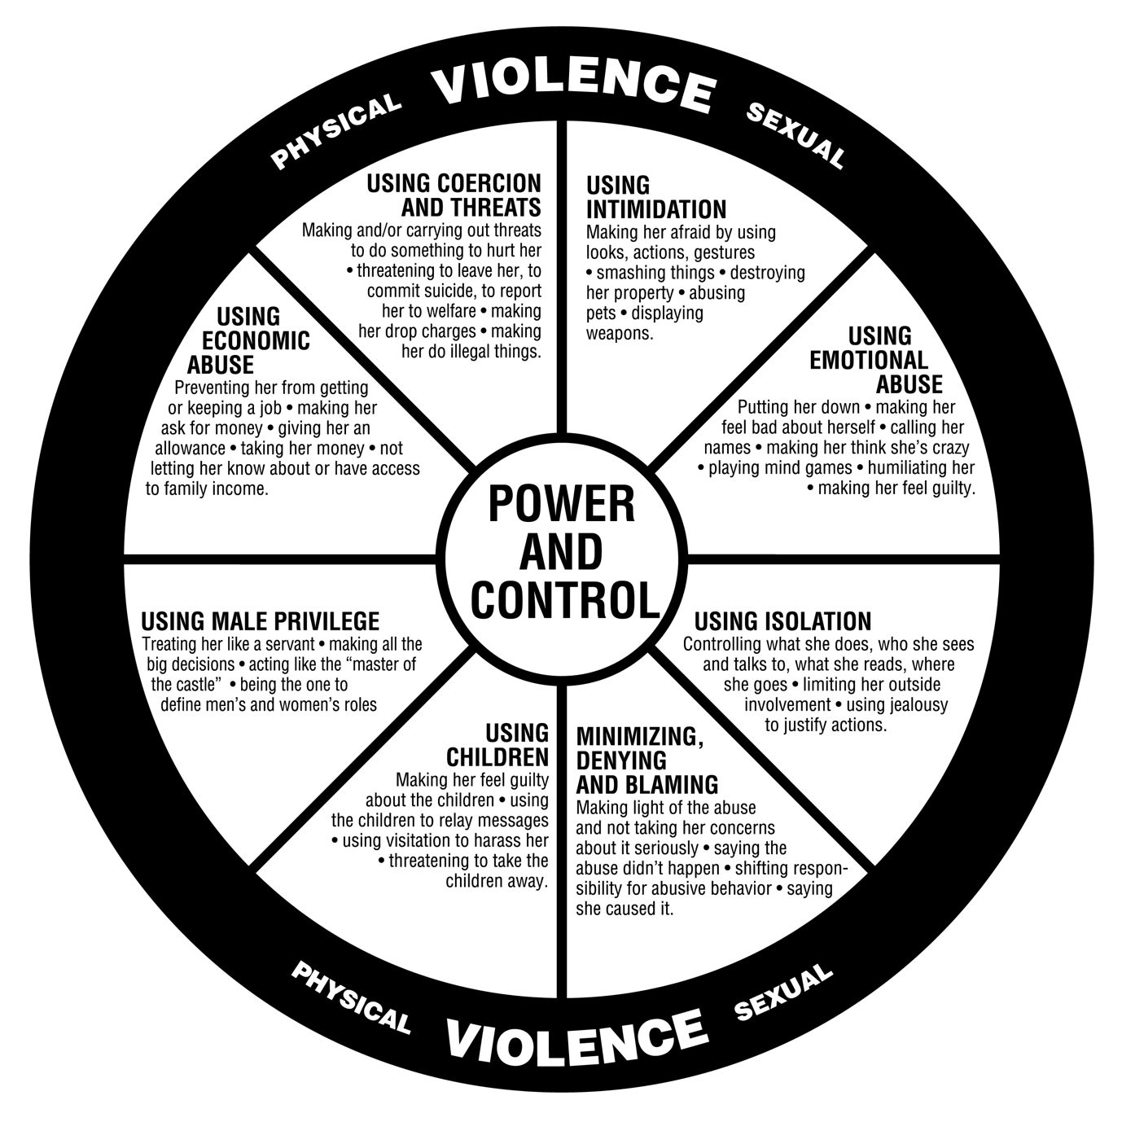

|  |  |  |
| --- | --- | --- |
| **Title** | **Description** | **Link / document** |
| **Safe lives Guidance** | The purpose of the Dash risk checklist is to give a consistent and simple tool for practitioners who work with adult victims of domestic abuse in order to help them identify those who are at high risk of harm and whose cases should be referred to a Marac meeting in order to manage their risk. |  |
| **MARAC referral form (includes DASH RIC)** | Multi-Agency Risk Assessment Conference (MARAC) uses a consistent comprehensive approach to risk assessing victims of domestic abuse, This helps to identify those most at serious risk of harm and identifying appropriate inventions to reduce that risk. The process will also enable a more effective way of sharing information between agencies and thus identifying risk that may have previously not been readily identified by the initial responding agency.  The purpose of this form is to enable referrals to be made into MARAC. |  |
| **Young people DASH RIC** | This Young People’s Checklist will help you to identify known risks in domestic abuse and include specific considerations in relation to young people to inform your professional judgement. |  |
| **Working with perpetrators** | The Framework aims to define and clarify the key capabilities (i.e.  knowledge, attitude and values, ethical practice, skills and reflection  and professional development) for working with men who use  substances (drugs and alcohol) and who perpetrate intimate partner  violence. It is aimed primarily at people who work within substance  use treatment services, but it also relevant to those who work with perpetrators of DA who misuse substances. | [Capabilities framework](https://www.kcl.ac.uk/ioppn/depts/addictions/research/drugs/Capabilities-Framework.pdf) |
| **Safety planning with adults/families** | Safety planning with victims of domestic abuse (adults). | [Resources](http://www.socialworkerstoolbox.com/category/domestic-abuse/domestic-abuse-parents/) |
| **Safety planning with children & young people** | Safety planning with children and young people. | [Resources](http://www.socialworkerstoolbox.com/category/domestic-abuse/domestic-abuse-children/) |
| **AVA toolkits** | Examples of assessment forms and guidance on risk management as well as guidance on working with perpetrators in drug/alcohol treatment and supporting children living with parental substance misuse and domestic violence. |  |
| **Power & Control Wheels** | The original wheels developed by the Domestic Abuse Intervention Programs (DAIP) as well as images that have underwent DAIP’s formal adaptation approval process. | [Power & control wheels](https://www.theduluthmodel.org/wheel-gallery/) |
| **Homicide Timeline** | ​​​​​​Resea​rch published and carried out by Dr Jane Monckton Smith looked at 372 cases of intimate partner homicide through interviews with bereaved families and public protection professionals. Through her study, published in the Violence Against Women Journal (VAW), Dr Jane Monckton Smith, Senior Lecturer in Criminology at the University of Gloucestershire, found an emerging pattern that could be broken down into eight separate stages. |  |
| **Expect respect healthy relationships toolkit** | Prevention/early intervention programme. | [Expect Respect healthy relationships toolkit](https://www.womensaid.org.uk/wp-content/uploads/2021/02/Expect-Respect-Healthy-Relationships-Toolkit.pdf) |
| **Spiralling / healthy relationships toolkit** | The tool kit is designed to be used by people working with children and young people of any age from 4 to 19 and over. Some of the later activities will not be suitable for younger children and will probably be used only with young people aged 11/12 and over. All of these activities can be developed and varied according to the age and abilities of the group. | [Spiralling Toolkit for safer, healthier relationships](http://thehideout.org.uk/wp-content/uploads/2015/07/spiralling_toolkit.pdf#page=95&zoom=100,0,198) |
| **Impact of domestic abuse on children by developmental level** | Outlines the possible effects of domestic abuse on a child by developmental level and identifies potential protective factors that may minimise the impact of abuse on the child. |  |

**DIRECT WORK**

***There are a number of direct work tools on the Tri.x council page:*** [***Tri.x procedures***](https://www.proceduresonline.com/resources/covid19/)

|  |  |  |
| --- | --- | --- |
| **Title** | **Description** | **Link / document** |
| **Under 4’s - attachment observation checklist** | The observation checklists describe some specific items that we should note when observing child- parent interactions. The items are all positively phrased, meaning that where positive attachments are in operation we will be able to observe the behaviours listed. |  |
| **Over 4’s** | There are a number of direct work tools on the Trix council page, CAFCASS and other links as below. | [CAFCASS direct work tools](https://www.cafcass.gov.uk/grown-ups/professionals/resources-for-professionals/)  [Tri.x procedures](https://www.proceduresonline.com/resources/covid19/) |
|  | Resources for assessing domestic abuse | [CAFCASS](https://www.cafcass.gov.uk/grown-ups/professionals/ciaf/resources-for-assessing-domestic-abuse/) |
|  | Child to Parent Violence and Abuse Risk Screening Tool |  |
|  | CAFCASS tools | [CAFCASS resources](https://www.cafcass.gov.uk/grown-ups/professionals/ciaf/resources-for-assessing-domestic-abuse/) |
|  | Social workers Toolbox | [Social workers toolbox: domestic abuse](http://www.socialworkerstoolbox.com/category/domestic-abuse/) |
|  | The Children’s Society | [What is domestic abuse](https://www.childrenssociety.org.uk/information/young-people/advice/domestic-abuse) |

**SOCIAL**

Social Media

Facebook group: ‘socialworkerstoolbox’

Twitter: most local and national organisations have a twitter handle, or try the #domesticabuse

YouTube: [Coercive Control - Where is the line?](https://youtu.be/DmbTqFH4x0w)

YouTube: [Kayleigh’s Love Story](https://youtu.be/WsbYHI-rZOE)

Books

Living with the Dominator: A book about the Freedom programme. Author: Pat Craven

Freedom Flowers: The effects of domestic abuse on children. Author: Pat Craven

Rose Madder. Author: Stephen King

In Control: Dangerous relationships and how they end in murder. Author: Jane Monckton-Smith

[The Reflective Journal for Practitioners Working in Abuse and Trauma](https://victimfocus-resources.com/products/the-reflective-journal-for-practitioners-working-in-abuse-and-trauma). Author: Dr Jessica Eaton

Movies/TV

Sleeping with the enemy (movie)

Berlin syndrome (movie)

Gaslight (movie)

Honour (ITV Drama)



**RESEARCH**

Ashley, C (ed) (2013)  
[Working with Risky Fathers: Fathers Matter Volume 3: Research Findings on working with domestically abusive fathers and their involvement with children’s social care services](https://books.google.co.uk/books/about/Working_with_risky_fathers_Fathers_Matte.html?id=zVGz9WnkYKYC&redir_esc=y)  
Family Rights Group

Bagshaw, D; Brown, T; Wendt, S; Campbell, A; McInnes, E; Tinning, B; Batagol, B; Sifris, A; Tyson, D; Baker, J and Fernandez Arias, P (2011)  
‘[The effect of family violence on post-separation parenting arrangements: The experiences and views of children and adults from families who separated post-1995 and post-2006](https://aifs.gov.au/publications/family-matters/issue-86/effect-family-violence-post-separation-parenting-arrangements)’  
*Family Matters*, Number 86, p49-61

Buckley, H; Holt, S and Whelan, S (2007)  
‘[Listen to me! Children’s experiences of domestic violence](http://onlinelibrary.wiley.com/doi/10.1002/car.995/abstract)‘  
*Child Abuse Review*, Volume 16, Issue 5, p296-310

Devaney, J (2015)  
‘[Research Review: The Impact of Domestic Violence on Children](http://www.pbni.org.uk/wp-content/uploads/2015/02/IPJ-2015-JohnDevaney_IPJ.pdf)’  
*Irish Probation Journal*, Volume 12, p79-94

Department of Health (2009)  
[Improving Safety, Reducing Harm – Children, young people and domestic violence – A practical toolkit for front-line practitioners](http://webarchive.nationalarchives.gov.uk/+/www.dh.gov.uk/en/Publicationsandstatistics/Publications/PublicationsPolicyandGuidance/DH_108697)  
Department of Health

Featherstone, B and Peckover, S (2007)  
‘[Letting them get away with it: Fathers, domestic violence and child welfare](http://csp.sagepub.com/content/27/2/181.abstract)’  
*Critical Social Policy*, Volume 27, Number 2, p181-202

Holt, S; Buckley, B and Whelan, S (2008)  
‘[The impact of exposure to domestic violence on children and young people: A review of the literature](http://www.ncbi.nlm.nih.gov/pubmed/18752848)’  
*Child Abuse and Neglect*, Volume 32, Number 8, p797-810

Home Office (2013, updated 2016)  
[Domestic Violence and Abuse: Guidance](https://www.gov.uk/guidance/domestic-violence-and-abuse)

Humphreys, C and Absler, D (2011)  
‘[History repeating: child protection responses to domestic violence](http://onlinelibrary.wiley.com/doi/10.1111/j.1365-2206.2011.00761.x/abstract)’  
*Child & Family Social Work*, Volume 16, Issue 4, p464-73

Humphreys, C; Houghton, C and Ellis, J (2008) (eds)  
[Literature Review: Better Outcomes for Children and Young People Experiencing Domestic Abuse – Directions for good practice](http://www.gov.scot/resource/doc/234221/0064117.pdf)  
Scottish Executive

Humphreys, C; Thiara, R K; Sharp, C and Jones, J (2015)  
[‘Supporting the Relationship Between Mothers and Children in the Aftermath of Domestic Violence’](http://www.jkp.com/uk/domestic-violence-and-protecting-children.html)

in Stanley, N and Humphreys, C (2015) (eds) *Domestic Violence and Protecting Children: New Thinking and Approaches*  
Jessica Kingsley Publishers

Laing, L and Humphreys, C with Cavanagh, K (2013)  
[Social work and domestic violence: developing critical and reflective practice](https://uk.sagepub.com/en-gb/eur/social-work-and-domestic-violence/book228441)  
Sage Publishing

Lapierre S (2008)  
‘[Mothering in the context of domestic violence: the pervasiveness of a deficit model of mothering](http://onlinelibrary.wiley.com/doi/10.1111/j.1365-2206.2008.00563.x/abstract)’  
*Child and Family Social Work*, Volume 13, Issue 4, p454-63

Katz (2016)

[Beyond the Physical Incident Model: How Children Living with Domestic Violence are Harmed By and Resist Regimes of Coercive Control](https://onlinelibrary.wiley.com/doi/abs/10.1002/car.2422)

Katz, E. (2016)  Beyond the Physical Incident Model: How Children Living with Domestic Violence are Harmed By and Resist Regimes of Coercive Control. *Child Abuse Rev.*,  25:  46– 59.

Katz, et. al. (2020)

[When Coercive Control Continues to Harm Children: Post-Separation Fathering, Stalking and Domestic Violence](https://onlinelibrary.wiley.com/doi/10.1002/car.2611)

Katz, E.,  Nikupeteri, A., and  Laitinen, M. (2020)  When Coercive Control Continues to Harm Children: Post-Separation Fathering, Stalking and Domestic Violence. *Child Abuse Rev.*,  29: 310– 324.

[Women’s Aid Research Blog](https://www.womensaid.org.uk/evidence-hub/research-and-publications/safe-blog/)

[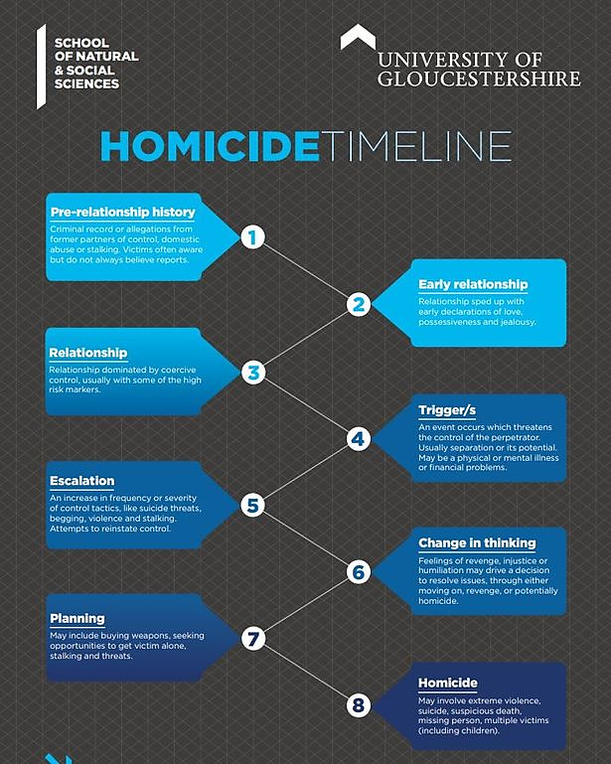](https://www.glos.ac.uk/content/the-homicide-timeline/)