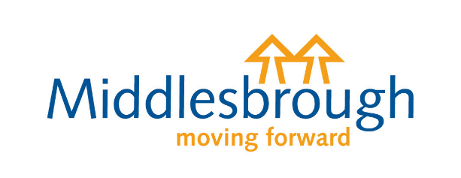
HOME TO SCHOOL TRANSPORT

EDUCATION & INSPECTIONS ACT 2006
Renewal 2023/24
Implementation of Universal Credit in the Middlesbrough area may affect changes to transport eligibility criteria and may require any application to be re-assessed for the start of the new academic year 2023/24.

PUPIL DETAILS

First Name
Surname
Address
Enter Name of School and Year Group from September 2023/2024
Pupil Date of Birth
School:
Year Group:

Postcode:

PARENT/GUARDIAN/CARER INFORMATION

Is your child eligible for free school meals?
(Please X as appropriate)
For additional information please see overleaf

Tel. No
First Name
Surname

Email
No
Yes

DECLARATION

I declare that the information given on this form is correct.
Signature of Parent/Guardian/Carer ____________________ Date of Signature _________________

The completed form should be returned by email to eia@middlesbrough.gov.uk or by post to: Integrated Transport Unit, Resolution House, Cargo Fleet Lane, Middlesbrough TS3 8AL. If you have any queries regarding assistance with Home to School Transport email eia@middlesbrough.gov.uk .
If your application does not include the required evidence or documentation it will be deemed incomplete and returned to you. Your application will not be initially assessed for eligibility until it is deemed complete. Any initial assessment will be carried out within 20 working days of the date of receipt complete.
All applications must be received complete by Friday 14th July 2023. Applications received after this date may not be assessed for eligibility or processed prior to the start of the September 2023 term.

Home to School Transport
Renewal Year 8-11
Any renewal application needs to be submitted with no changes from previous information or circumstances held for the student/family. Any changes in circumstances will require submission of a new application. Please see Application 2 on the Councils Website @ www.middlesbrough.gov.uk
All renewal applications must be submitted and deemed complete by Friday 14th July 2023 at the very latest. Applications received to be assessed for eligibility or deemed complete after this date may not be processed prior to the start of the new September 2023 Term.

How to apply
Refund of fuel or fares
- If you are applying to renew any refund of fuel or fares and your child(ren) are in receipt of free school meals
  - Complete and return this form
- If you are applying to renew any refund of fuel or fares and your family are in receipt of maximum working tax credit or meet the universal credit threshold
  - Complete and return this form plus send us pages 1, 2, 3, & 4 of your entitlement to the maximum level of Working Tax Credit for the year April 2023 to April 2024 or provide evidence of Universal Credit entitlement.
Renewal of existing bus pass on a designated school bus
- If you are applying to renew a bus pass on a designated school bus and your child(ren) are in receipt of free school meals
  - Complete and return this form plus
  - Responsibility Form – Appendix 1
  - Photo – head and shoulders passport style – no filters , sun glasses, pouting etc
- If you are applying to renew a bus pass on a designated school bus and your family are in receipt of maximum working tax credit or meets the universal credit net earning threshold of £7400 and under
  - Complete and return this form plus
  - Responsibility Form – Appendix 1
  - Photo – head and shoulders passport style – no filters , sun glasses, pouting etc
  - Pages 1, 2, 3, & 4 of your entitlement to the maximum level of Working Tax Credit for the year April 2023 to April 2024 or provide evidence of Universal Credit entitlement
  - Emergency Care and Contact Form
Renewal of Placement Allocation
- If you are applying to renew any refund of fuel or fares
  - Complete and return this form
- If you are applying to renew all types of designated home to school transport
  - Complete and return this form (Refund of fares only) plus
  - Responsibility Form – Appendix 1
  - Photo – head and shoulders passport style – no filters , sun glasses, pouting etc
  - Emergency Care and Contact Form

