Local Government (Miscellaneous Provisions) Act 1976
Section 50(3) Notification

Without prejudice to the provisions of Section 25 of the Road Traffic Act of 1972, the proprietor of a Hackney Carriage or of a Private Hire vehicle licensed by a district council shall report to them as soon as reasonably practicable, and in any case within seventy two hours of the occurrence thereof, any accident to such hackney carriage or private hire vehicle causing damage materially affecting the safety, performance or appearance of the hackney carriage or private hire vehicle or the comfort or convenience of persons carried therein, (failure to do so is an offence and will result in action being taken against you).

Section A - The Vehicle
Private Hire Vehicle

Hackney Carriage Vehicle

Licence Type
(Please Tick)

Registration Mark Plate Number

Section B – The Notifier
Badge Number I am not a Licensed Driver

Name & Address

Telephone Number

E- Mail Address

Section C – The Driver
Badge Number

Name & Address

Telephone Number

E- Mail Address

Section D – The Accident
When was the accident ?
(Date and Time)

Where was the
accident?

Please give brief description of how the accident happened:

YES | NO
If the car is in your possession can it be safely driven?

If the Car was recovered where is it now?

If other vehicles were involved please give details below:
(If more than one vehicle was involved provide details on a separate sheet)

Name of Driver

Vehicle Registration

Section E – Vehicle Damage
Using this key, please indicate clearly on the diagram below the position and type of damage caused as a result of this accident only:

Key: S= Scratch; D = Dent; M = Missing

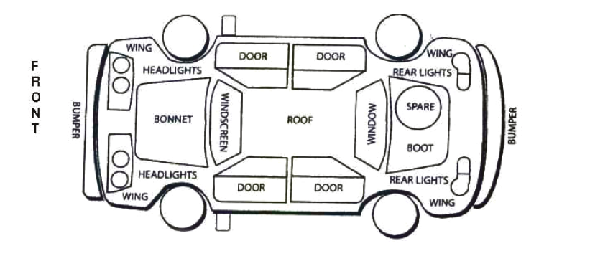

Please note that unseen damage may have occurred to the chassis of the vehicle
My vehicle licence plates are being returned to the Licensing Office with this notification
YES | NO

In making this notification, I confirm the following:
a) The information given is true to the best of my knowledge
b) I/We understand that it is a criminal offence to make a false statement or omit any material particular from this document
By completing this document you give Middlesbrough Council the authority to collect and retain information about you for the purpose of licensing yourself as a Private Hire Vehicle and/or Hackney Carriage driver. In order to grant a licence we may need to check this information with other enforcement agencies, local authorities or government departments.
We must protect the public funds we handle so we may use the information you have provided on this form to prevent and detect fraud. We may also share this information with other enforcement agencies including those organisations which handle public funds. Middlesbrough Council will not disclose information about you unless the law permits.
Middlesbrough Council is the Data Controller for the purposes of the Data Protection Act. If you want to know more about the information the Authority holds about you, or the way the Authority uses that information, please contact the Data Protection Officer, Middlesbrough Council, PO Box 500, Town Hall, Middlesbrough, TS1 9FT or refer to Data Protection at www.middlesbrough.gov.uk

Signed Dated

Print Name

Email this form to: licensing@middlesbrough.gov.uk

For Customer Service Centre Use Only
Date Notification Received: Checked By:
Vehicle Licence Plates Returned to Office (please tick) YES NO

