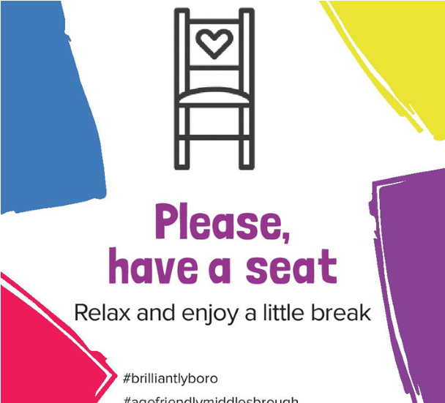
Please have a seat

sign up

Your name
Business name

Business address I require:
A window sticker
A chair sticker
A chair

Telephone number

Email address

We can offer access to our toilet facilities
We can offer water to drink
I would like to receive Age Friendly E-bulletin and receive information about Age Friendly initiatives and events

I agree to provide a chair in our premises. We would love you to display our sticker to promote Please have a seat campaign. Please talk to us if you think that might be an issue.

By completing this form you are giving consent for your information to be stored with Public Health South Tees, Middlesbrough Council. Middlesbrough Council operates within the guidelines set out within the General Data Protection Regulation and polices relating to data protection can be viewed upon request.

How to sign up?
Sign up to the campaign by emailing the completed form to
agefriendly@middlesbrough.gov.uk
or you can send it via post to Public Health South Tees, the Live Well Centre, Dundas House, Middlesbrough, TS1 1HR

